Project LIFE’s Summer Bucket List BINGO Guide
Rules: The game runs July 1-August 27. Achieve a BINGO by completing 4 squares in a row. BINGOs can be made vertically, horizontally, or diagonally. Or, you can also complete each corner instead of 4 in a row. This guide will share what needs to be done to complete each square.
Challenges, Prizes, and Submissions:
- 4 in a row earns a $25 VISA card
- 4 corners earns a $25 VISA card
- 10 completed squares earns a $50 VISA card.
**Only one prize will be awarded per contestant.

Keep track of the proof detailed for each square’s explanation. When you have completed the challenge of 4 or 10 squares, submit your board. In one email, send your completed guide and all proof to infoprojectlife@umfs.org by 8/27. Prizes will be mailed after the completed entries have been checked by the team.
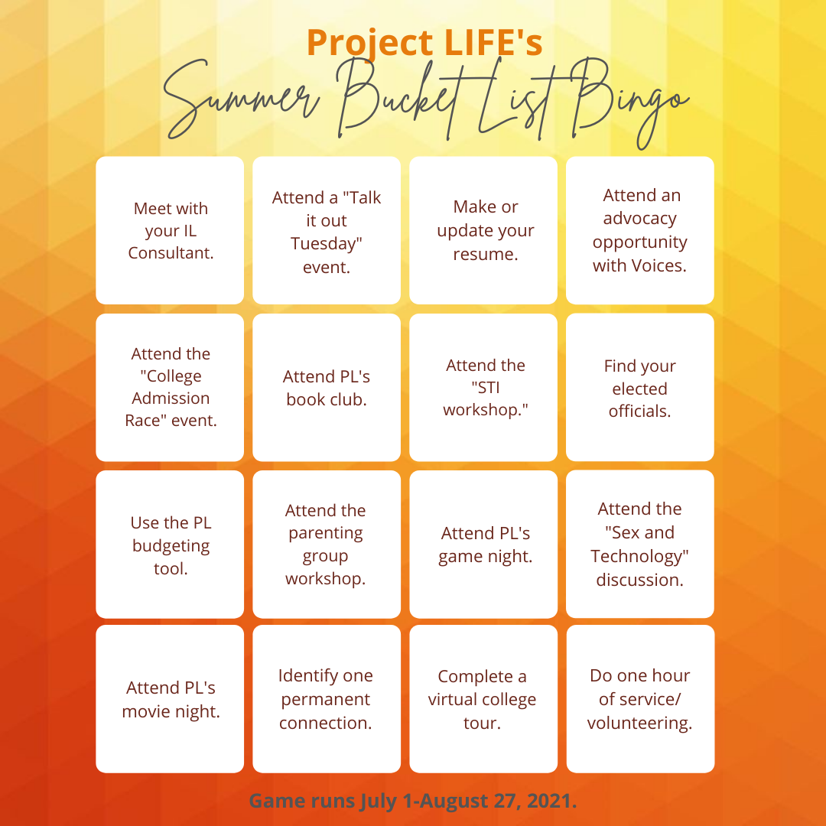
Square Explanations
Work directly in this document. Use the highlight tool to highlight the title of a square you are completing. Complete any information prompted for in the section. If you have questions about a square or its required proof, a lead PL staff member is listed for each one and is available to help.
Meet with your IL Consultant.
- Lead: your regional consultant
- Date: on your own time between 7/1-8/27
- What: Reach out to your consultant and plan a time to meet or talk with them over the phone or through Ring Central. You can come with questions or needs to discuss, or just get to know each other. Aim for at least 15 minutes. You can find your regional consultant using the map and based on your region here: www.vaprojectlife.org.
- Proof:
  - Met with consultant on this date: _____________
  - My consultant and I talked about: _____________
  - Your consultant will keep track of this meeting, too.

Attend a “Talk it Out Tuesday” event.
- Lead: Jamesia Harrison
- Dates: July 6, 20, August 3, 17 at 5:30-6:00 pm
- What: Register for this event here: https://umfs.formstack.com/forms/project_life_talk_it_out_tuesdays
if you have not already registered for Talk it out Tuesdays. Attend one session of your choosing and enjoy connecting with your peers.
- Proof:
  - Event registration is completed by youth/worker/foster parent. See link above.
  - Attended this date: _____________
  - The event lead will keep track of attendance.
Make or update your resume.
- Lead: your regional consultant
- Date: on your own time between 7/1-8/27
- What: For help creating a resume, you can use this link: https://novoresume.com/career-blog/how-to-write-a-resume-guide. You can also reach out to your consultant for help. (This will knock out a second square, too!)
- Proof:
  - Tell what updates you made to your resume: _____________
  - Attach your resume in your bingo board submission email.
Attend an advocacy opportunity with Voices.
- Lead: Sophia Booker
- Dates and Events:
  - Voices Racial Truth and Reconciliation Week has been moved to Aug 22-28.
  - The schedule of events will be announced once changes are made.
  - TBD: This will be a round table discussion about authentically engaging youth and young adults around the topic of racial truth and reconciliation.
  - TBD: an in-person community walk.
- What: See the events with descriptions above. Sign up here to receive updates sent through email as more information becomes available. https://forms.office.com/r/d6YMPTqTWG
- Proof:
  - Event registration is completed by youth/worker/foster parent. See link above.
  - Take a picture of you at the walk or participating in one of these activities and attach it to your bingo board submission email.
Attend the “College Admission Race” event.
- Lead: George Mack partnering with ECMC
- Date: August 4th at 4:00 pm-5:00 pm
- What: Register for this event here: https://umfs.formstack.com/forms/project_life_registration_form_college_race. The College Admissions Race workshop is an interactive activity where students participate as members of a college admissions committee to determine which applicants should be granted admissions to their college based on the values of their respective school. Students learn how colleges approach reviewing college applications and the various factors that schools may consider when making admissions decisions.
- Proof:
  - Attended on this date:______________
  - Event registration is completed by youth/worker/foster parent. See link above.
  - The event lead will keep track of attendance.
Attend PL’s Book Club.
- Lead: Jamesia Harrison
- Date: July 20 at 1:30 pm, July 22 at 5:00 pm, August 17 at 1:30 pm
- What: Register for these events here: https://umfs.formstack.com/forms/project_life_registration_form_book_club by this July 6 to receive the book in the mail. (You can provide the book on your own if you miss the registration date, and still register to attend one of the discussions.) Read the book, “I am Not Dying With You Tonight” by Gilly Segal and Kimberly Jones. Use the meeting link from your registration email to attend one session of your choosing to discuss the book with your peers. (The three sessions will feature the same discussion questions.)
- Proof:
  - Attended on this date: ______________
  - Event registration is completed by youth/worker/foster parent. See link above.
  - The event lead will keep track of attendance.
Attend the “STI Workshop.”
- Lead: Melissa Lee partnering with the Virginia League of Planned Parenthood
- Date: July 13 from 1:00-2:00 pm
- What: Register for this event here: https://umfs.formstack.com/forms/project_life_registration_form_vlpp. This event will be lead by the Virginia League for Planned Parenthood. Youth will be given an overview of sexually transmitted infections, including symptoms, prevention, treatment methods, and testing options.
- Proof:
  - Attended on this date: ______________
  - Event registration is completed by youth/worker/foster parent. See link above.
  - The event lead will keep track of attendance.
Find your elected officials.
- Lead: Pierre Hall
- Date: on your own time between 7/1-8/27
- What: Go to this website: https://www.house.gov/representatives/find-your-representative and follow the prompts and review the information to answer the questions below.
- Proof: (Answer all of these questions.)
  - What is your zip code? ______________
  - What district are you in? ______________
  - Who is your state delegate? ______________
  - What party are they in? ______________
  - Who is your state senator? ______________
  - What party are they in? ______________

Use the PL budgeting tool.
- Lead: Aros Herndon
- Date: on your own time between 7/1-8/27
- What: Go to this website: https://www.vaprojectlife.org/money-management/ and click on the Budget Tool. Read and complete this tool, either by printing it and completing it by hand or saving it as a PDF and completing it electronically.
- Proof:
  - Include a copy of or picture of your completed monthly budget using the tool provided.
Attend the parenting group workshop.
- Lead: Kelly Trump
- Date: July 21 at 5:30-6:30 pm
- What: This event is for Project LIFE youth who have young children ages 0-3. Register for this event here:
https://umfs.formstack.com/forms/project_life_registration_form_parenting_group.
Attend virtually and learn two methods that you can do to help your child’s brain growth.
- Proof:
  - Attended on this date: ______________
  - Event registration is completed by youth/worker/foster parent. See link above.
  - The event lead will keep track of attendance.
Attend PL’s game night.
- Lead: Sophia Booker
- Date: July 22 6:00pm – 8:00pm
- What: Register for this event https://umfs.formstack.com/forms/project_life_registration_form_summer_game_night.Join us for a fun night of gaming! Youth will be able to participate in an across-platform gaming session that will be streamed live on Twitch or YouTube. Games will include Apex Legends, Among Us, Knockout City, and more. All games listed are cross platform, meaning that they can be played from multiple devices (Mac/PC, PlayStation, Xbox, Nintendo Switch, Phone, etc). Sophia will send more information to the registered attendants as the event nears.
- Proof:
  - Attended on this date:______________
  - Event registration is completed by youth/worker/foster parent. See link above.
  - The event lead will keep track of attendance.
Attend the “Sex and Technology” discussion.
- Lead: Melissa Lee
- Date: August 9 from 1:00-2:00 pm
- What: Register for this event here: https://umfs.formstack.com/forms/project_life_registration_form_vlpp.Youth attendees and the facilitator will discuss the role that technology plays in dating and sexual relationships.
- Proof:
  - Attended on this date:______________
  - Event registration is completed by youth/worker/foster parent. See link above.
  - The event lead will keep track of attendance.
Attend PL’s movie night.
- Lead: Sophia Booker
- Date: August 12 from 6:00-8:00 pm
- What: Register here: https://umfs.formstack.com/forms/project_life_registration_form_summer_movie_night.This will be a virtual movie night through Kosmi. Grab some popcorn, sit back, and relax with Project LIFE for movie night! Youth will have the opportunity to vote on what they would like to watch from a list of three movies. Come join us! Sophia will send more information to the registered attendants as the event nears.
- Proof:
  - Attended on this date:______________
  - Event registration is completed by youth/worker/foster parent. See link above.
  - The event lead will keep track of attendance.
Identify one permanent connection.
- Lead: George Mack
- Date: on your own time between 7/1-8/27
- What: Think about your permanent connection, and complete the questions in the proof section.
- Proof: Answer the following questions below right in this document.
  - Who is your permanent connection? ______________
  - What is their relationship to you? ______________
  - How did you meet them? ______________
  - How long have you known them? ______________
  - What is their impact on your life? ______________
Complete a virtual college tour.
- Lead: Pierre Hall
- Date: on your own time between 7/1-8/27
- What: go to this website: https://www.youvisit.com/ and complete a virtual tour. Then for credit, answer the questions in the proof section.
- Proof: Answer the following questions below right in this document.
  - What college/university did you tour? ______________
  - Where is this college or university located? _____________
  - Does this university offer a major that you are interested in? __________
    - if so what major? _________________
  - Who is the current University President? __________________
  - Using your geography knowledge, list 4 campuses that are in VA:
    - _________
    - _________
    - _________
    - _________
Do one hour of service/volunteering.
- Lead: Aros Herndon
- Date: on your own time between 7/1-8/27
- What: Complete one hour of service of your choice. This could be completed on your own or through a formal opportunity. Examples of services to complete on your own: pick up trash on a trail or at a park, walk a dog, pass out food at a foodbank, take clothes to a donation place, assist an elderly person,
- Proof: Answer the following questions below right in this document.
  - Date completed: ______________
  - Activity that you completed: ______________
  - Why did you choose this activity: ______________
  - Take a selfie of you completing your activity of choice and attach it to the bingo board submission email.

