CHAFEE FOSTER CARE PROGRAM FOR SUCCESSFUL TRANSITION TO ADULTHOOD

State Fiscal Year 2026
GUIDELINES FOR FUNDING

Chafee Program
And
Education and Training Voucher Program

Virginia Department of Social Services
Division of Family Services
Foster Care Unit
5600 Cox Road
Glen Allen, Virginia 23060

E-mail: va.ilp@dss.virginia.gov
Services for Older Youth
Foster My Future

GUIDELINES FOR:

VIRGINIA’S
CHAFEE PROGRAM
AND
EDUCATION AND TRAINING VOUCHER PROGRAM

State Fiscal Year 2026

TABLE OF CONTENTS

SECTION 1 - GENERAL INFORMATION 3

SECTION 2 - CHAFEE PROGRAM 5

SECTION 3 - EDUCATION AND TRAINING VOUCHER PROGRAM 13
SECTION 4 - SUBMISSION AND REPORTING REQUIRMENTS 19
SECTION 5 - SUB-RECIPIENT MONITORING REVIEW/AUDIT 21
SECTION 6 - NATIONAL YOUTH IN TRANSITION DATABASE (NYTD) 23
SECTION 7 - ADDITIONAL CHAFEE PROGRAM RELATED SERVICES 27
APPENDIX A 29
APPENDIX B 33
APPENDIX C 37

SECTION 1 - GENERAL INFORMATION

PURPOSE OF FUNDING PACKAGE
The purpose of this package is to provide guidance, instructions, and requirements for obtaining and expending federal and state funds available under the John H. Chafee Foster Care Program for Successful Transition to Adulthood (Chafee Program) and the Education and Training Voucher (ETV) Program.

Funds available through the Chafee and ETV Programs shall be used to supplement and not supplant (or take the place of) any other funds which are available for the same general purposes in the State. This package includes the applications for both programs.

There are no local match requirements to procure goods and/or services for eligible youth using budget line (BL) 861 – ETV and BL 862 – Chafee Program. However, local departments of social services (LDSS) that need to fund Independent Living (IL)-related training or activities for staff and operation costs using Chafee funds must transfer needed funds from BL 862 to BL 855 (Service Administration) in LASER. Funds cannot be transferred from BL 861 to BL 862 or BL 855. There is a required local match for BL 855. LDSS have the responsibility for program performance and accounting costs charged to BL 855.
For state fiscal year (FY) 2026, Chafee and ETV total allocations will be dispersed in June 2025. This funding package provides further explanation of the allocation formulas and instruction for the application and mid-year review processes.
Notices/Reminders for FY 2026
- Applications for Chafee and ETV funding for FY 2026 are due no later than March 7, 2025. In order to receive funding, all application materials must be submitted in a timely manner. See the respective program sections of this funding package for instructions. All application materials may be submitted by email to va.ilp@dss.virginia.gov. (See Appendix A.)

- LDSS Budget Lines (BL) 861 (ETV) and 862 (Chafee) expenditures must be used to pay for goods and/or services listed in Section 2 for the Chafee Program and Section 3 for the ETV program. If there are goods and/or services needed that are not listed, send an e-mail to va.ilp@dss.virginia.gov with justification stating the need and the purchase amount. The request will be reviewed and if no additional information is needed, a decision granting an approval to purchase, or denial will be provided. Approval of any request is dependent on availability of funds.

- LDSS are required to submit detailed information on the Chafee and ETV Quarterly Reports regarding all gift cards, money cards, and/or certificates purchased using funds from BL 861and BL 862. In addition, written approval from the director or their designee must be received prior to the purchase. Youth must sign a dated document acknowledging receipt of cards and/or certificates.

- Chafee funds cannot be used to:
- provide foster parent training
- purchase real estate
- supplement clothing vouchers
- provide transportation for secondary education (middle/high school)

- Chafee and ETV funds cannot be used to provide services to undocumented youth without legal permanent status (Green Card).

- All Chafee Program and ETV services paid for and/or provided by LDSS on behalf of youth must be documented in OASIS by the LDSS as required by the federal National Youth in Transition Database (NYTD) (45 CFR 1356.80-86), as well as by VDSS. Please note that an IL service is provided by an LDSS if it is delivered by: 1) LDSS staff or an agent of the LDSS, including a foster parent, group home staff, or childcare institution staff; or 2) provided pursuant to a contract between an LDSS and a provider, agency, or any other entity regardless of whether the contract includes funding for the particular service.

- Eligible youth are encouraged to participate in the NYTD survey at ages 17, 19, and 21 when included in the federal NYTD cohort. To increase participation, LDSS are required to offer incentives to youth who participate in the NYTD survey. For consistency, the amount of the incentive is as follows: $25.00 at age 17; $50.00 at age 19; and $100.00 at age 21 If gift cards are provided, please follow the gift card purchase guidelines as outlined above. Incentives must be taken from the Chafee allocation (BL 862).
.
- ETV allocations (BL 861) will be awarded based on the number of eligible youths submitted by the LDSS and prior history use of funds. It is important to provide an accurate count of the number of youths to be served in order to avoid returning monies to the federal government due to disproportionate projections of eligible ETV youth.

- Chafee Program allocations (BL 862) will be based on average number of youths in foster care over the age of 13 as determined by VDSS.

- LDSS will receive 100% of eligible Chafee and ETV allocations at the beginning of June 2025.

SECTION 2 - CHAFEE PROGRAM

PURPOSE OF THE CHAFEE PROGRAM
The John H. Chafee Program for Successful Transition to Adulthood (Chafee Program) supports all youth who experience foster care at age 14 or older and who age out of foster care up to age 23. The purpose of this program is to empower youth by offering resources and supports to meet the youth individual needs to help them succeed by providing flexible funding for the following:
- Helping youth attain a high school diploma and post-secondary education or vocational training
- Training and opportunities to practice daily living skills such as financial literacy and driving instruction
- Achieving meaningful, permanent connections with caring adults
- Engaging in age and developmentally appropriate activities which promote positive youth development
- Experiential learning that reflects what their peers in intact families’ experience

COLLABORATING TO ACHIEVE DESIRED OUTCOMES
The Chafee Program focuses on collaborating and coordinating IL services with other federal, state and community-based agencies and providers that serve youth. VDSS continues to use the six NYTD outcomes for evaluating efforts in preparing youth for adulthood, self-sufficiency, and interdependence as they exit the foster care system.
The six desired outcomes are:
- Increase youth financial self-sufficiency
- Improve youth educational attainment
- Increase youth positive connections with adults
- Reduce experience with homelessness among youth
- Reduce high-risk behavior among youth
- Improve youth access to health insurance

ELIGIBILITY
The following youth are eligible to receive Chafee (BL 862) funded IL services:
- All youth/young adult in foster care (including Fostering Futures) ages 14 up to age 21.
- All youth/young adult who transitioned out of foster care (Fostering Futures) at any time after turning 18 years of age, but have not yet attained 23 years of age, may receive limited assistance based on availability of Chafee Program funds.
- All youth who left foster care through adoption or participated in Kinship Assistance Programs (State Funded Kinship Subsidy, KinGAP, Adoption Assistance) at age 16 and over may receive limited assistance based on availability of Chafee Program funds.
- Youth who had been in foster care between the ages of 14 and 21 and left for some reason other than aging out, participation in a Kinship Assistance Program or adoption, may receive limited assistance based on availability of Chafee Program funds.

LENGTH OF TIME PARTICIPANTS ARE ELIGIBLE TO RECEIVE CHAFEE (BL 862) FUNDED GOODS AND/OR SERVICES
Eligible youth are to receive Chafee funded goods and/or services as indicated in their transition plan which is approved by the court and/or the LDSS and reviewed at least annually.
Youth who were in foster care on their 18th birthday are to continue to receive Chafee Program funded goods and/or services from LDSS until their 23rd birthday if:

- They are participating in the Fostering Futures program (see below); or
- They continue to receive services through the LDSS, and they willingly agree to cooperate with all services as documented in the OASIS case record, service plan, and transition plan.

Service plans, life skills assessments, and transition plans are not required for youth who are age 21 and over and receiving IL services, however, service(s) must be documented in OASIS.

Fostering Futures Program
Youth who qualify for Fostering Futures are those who reach age 18 years of age and:

- Were in foster care through a LDSS in Virginia at the time they turned 18 years old but have not yet turned 21, including those who were in care under an entrustment, and those who were in non-custodial foster care; or
- Are in Permanent Foster Care (PFC) with a valid PFC agreement approved by the court; or
- Youth who were in foster care at the time of commitment to the Virginia Department of Juvenile Justice (DJJ) and are released from DJJ after age 18 who are not yet 21.
All eligible youth shall be in the Fostering Futures program on their 18th birthday (or on release from DJJ) with the following exception:
- Youth who are full-time students expected to complete secondary schooling or equivalent training before reaching age 19 (per Section 14 A.4.1.) and who are appropriately placed in a group home or residential placement prior to age 18 and expected to continue in such a placement, will continue in their current foster care status and placement until they complete school or it becomes clear that they will not complete school prior to their 19th birthday in accordance with Section 406(a) of the Social Security Act. At the time of completion of or withdrawal from secondary schooling, these young adults shall be immediately transitioned into the Fostering Futures program.
Participants in the Fostering Futures program must meet one of the following five participation conditions to remain eligible:

- Completing secondary education or a program leading to an equivalent credential (e.g., General Education Diploma);
- Enrolled full-time or part-time (at least half-time) in an institution that provides post-secondary education or vocational training;
- Participating in a program or activity designed to promote or remove barriers to employment;
- Employed at least 80 hours per month; or
- Incapable of engaging in any of the above activities due to a medical condition.
Youth participating in the Fostering Futures program can continue to receive IL services from the LDSS. All IL services provided to youth in Fostering Futures through BL 862 will need to be documented on the Chafee Program quarterly reports and in OASIS.

BASIC PROGRAM REQUIREMENTS
Each participating LDSS is required to:
- Assist each eligible youth in completing a life skills assessment
- Partner with the youth to complete a Transition Plan
- Pay for or provide IL goods and/or services
- Evaluate services for effectiveness

Life Skills Assessment
Federal NYTD regulation describes an independent living (IL) needs assessment, also known as life skills assessment, as “a systematic procedure to identify a youth’s basic skills, emotional and social capabilities, strengths and needs to match the youth with appropriate independent living services.” A life skills assessment may address knowledge of basic living skills, job readiness, money management abilities, and decision-making skills.
A life skills assessment shall be conducted to assess the strengths and needs of youth in preparation for adulthood. The assessment shall be driven by the youth. It should be strength-based and collaboratively involve the birth parents and caretakers of the youth as appropriate. Information from the assessment should complement the information obtained during the comprehensive child and family assessment.

The assessment is to be administered to all youth 14 years of age and older in foster care.
- For youth already in foster care, within 30 days of the youth’s 14th birthday.
- For youth entering foster care after their 14th birthday, within 45 days of the youth’s entry into care.

The assessment must be re-administered at least every 12 months.

The VDSS preferred assessment is the Casey Life Skills Assessment (CLSA), which is a free tool that assesses the independent skills youth need to achieve their long-term goals. The Casey Life Skills Toolkit can be download at:

https://www.casey.org/casey-life-skills/

OASIS Documentation

The LDSS must document the type of life skills assessment that was administered and the date the assessment was completed for each youth 14 and over in the OASIS IL Information screen.

Chafee Program Transition Plan

As directed by the Fostering Connections to Success and Increasing Adoptions Act of 2008, and the Code of Virginia (§ 63.2-905.1), VDSS requires all youth, age 14 and over, regardless of their permanency goal, to have a transition plan. The transition plan must specify the IL services, activities, and supports needed to help the youth successfully transition to adulthood. In addition, during the 90-day period immediately prior to the youth turning 18 years old, the service worker, youth, and youth’s team must create a transition plan which documents the specific plans for the youth to successfully transition from foster care services to adulthood. All transition plans must be youth-driven, youth-friendly, based on a formal life skills assessment, and developed through a team process.

The transition plan must be completed within 30 days of the life skills assessment. It must be updated every 12 months as long as the youth continues to receive services. If a youth’s foster care case is closed at any time and then reopened (e.g., the youth exits Fostering Futures and then returns), the life skills assessment and transition plan are to be updated upon re-entry.

The current transition plan is to be submitted to the court as an attachment to the service plan for all foster care hearings (including Fostering Futures).

Template

There is one (1) VDSS transition plan template for all youth in foster care (including Fostering Futures) age 14 and over. There are portions of the plan that are only for older youth labeled “18 and Up”. All youth completing the transition plan in the 90 days prior to their 18th birthday, and annually thereafter, shall complete these additional sections while youth ages 14-17 will skip these sections for now. This template can be found on FUSION (Portfolios à Division of Family Services à Foster Care à Services For Older Youth) as the “Chafee Program Transition Plan”.

The template contains multiple sections and begins with a cover page for the youth which describes the transition plan process and purpose and is followed by tips for completing the transition plan. This information should be shared with the youth when they complete the life skills assessment, in preparation of the transition plan, so that the youth will enter the planning meeting with a better understanding of the “big picture”, their role, and who should be involved.

The remaining sections are to be completed collaboratively by the youth, their service worker, and members of their team in the transition planning meeting. Sections include: 1) youth information, 2) youth rights and responsibilities, 3) life skills domains and goals, 4) plan for successful transition, 5) permanent connections, and 6) signature page. Copies of the transition plan are to be provided to the youth and all members of their team, as well as retained in the youth’s file.

OASIS Documentation
After a transition plan is completed, the completion date must be documented in the OASIS IL Information screen. The transition planning meeting must be documented in OASIS as a case contact with the contact type as “Family Partnership Meeting” or “Child and Family Teaming Meeting” as appropriate.

Independent Living “IL” services include a broad range of activities, education, training, and services. The federal NYTD categories listed below include the services that the federal government and VDSS expect to be provided for youth, as appropriate. These services are consistent with achieving the federal outcomes as previously described:
- Academic Support: see “Academic support/secondary education support and financial assistance (Chafee/IL funds)” below.
  - Academic support/secondary education support and financial assistance (Chafee funds): Designed to help a youth complete high school or obtain a General Equivalency Degree (GED) and not enrolled in a post-secondary education institute (i.e., community college, university) or vocational training program. Services include the following: academic counseling; preparation for a GED, including assistance in applying for or studying for a GED exam; tutoring; help with homework; study skills training; literacy training; and help accessing educational resources. Academic support does not include a youth's general attendance in high school. This category also includes secondary education support to help a youth enter college. Services include the following: classes for test preparation, such as the Scholastic Aptitude Test (SAT); counseling about college; information about financial aid and scholarships; help completing college or loan applications; other supports such as college tours paid for or provided by the VDSS/LDSS. Secondary education financial assistance is payment provided by the VDSS and/or LDSS for education or training including allowances to purchase textbooks, uniforms, computers, and other educational supplies; tuition assistance; scholarships; payment for educational preparation and support services (i.e., tutoring), and payment for GED and other educational tests. If the youth meet eligibility criteria, then the LDSS must use Chafee funds (BL 862).

- Budget and financial management: assistance includes the following types of training and practice: living within a budget; opening and using a checking and savings account; balancing a checkbook; developing consumer awareness and smart shopping skills; accessing information about credit, loans and taxes; and filling out tax forms.
- Career preparation: services focus on developing a youth's ability to find, apply for, and retain appropriate employment. Career preparation includes the following types of instruction and support services: vocational and career assessment, including career exploration and planning, guidance in setting and assessing vocational and career interests and skills, and help in matching interests and abilities with vocational goals; job seeking and job placement support, including identifying potential employers, writing resumes, completing job applications, developing interview skills, job shadowing, receiving job referrals, using career resource libraries, understanding employee benefits coverage, and securing work permits; retention support, including job coaching; learning how to work with employers and other employees; understanding workplace values such as timeliness and appearance; and understanding authority and customer relationships.
- Education financial assistance: see “Post-secondary education support/financial assistance (ETV funds)” below.
  - Post-secondary education support/financial assistance (ETV funds): designed to assist youth, who has completed high school or obtained their GED and accepted/enrolled in a post-secondary education institution (i.e., community college, university) or vocational training program by covering the following expenses: tuition and fees; room and board; computer and printer; allowances for books, supplies and transportation; special study projects related to education; child care and other related expenses. If the youth meet eligibility criteria for the ETV Program, then the LDSS must use the ETV funds (BL 861) for post-secondary educational expenses and document the service in OASIS as “Post-Secondary Education Support.”
- Employment programs or vocational training: designed to build a youth's skills for a specific trade, vocation, or career through classes or on-site training. Employment programs include a youth's participation in an apprenticeship, internship, or summer employment program and do not include summer or after-school jobs secured by the youth alone. Vocational training includes a youth's participation in vocational or trade programs in school or through nonprofit, commercial or private sectors and the receipt of training in occupational classes for such skills as cosmetology, auto mechanics, building trades, nursing, computer science, and other current or emerging employment sectors. If the youth meet eligibility criteria for the ETV Program, then the LDSS must use the ETV funds (BL 861) for post-secondary educational expenses and document the service in OASIS as “Post-Secondary Education Support.”
- Family support and healthy marriage education: include education and information about safe and stable families, healthy marriages, spousal communication, parenting, responsible fatherhood, childcare skills, teen parenting, and domestic and family violence prevention.
- Health education and risk prevention: include providing information about hygiene, nutrition, fitness and exercise, and first aid; medical and dental care benefits, health care resources and insurance, prenatal care and maintaining personal medical records; sex education, abstinence education, and HIV prevention, including education and information about sexual development and sexuality, pregnancy prevention and family planning, and sexually transmitted diseases and AIDS; substance abuse prevention and intervention, including education and information about the effects and consequences of substance use (alcohol, drugs, tobacco), and substance avoidance and intervention. Health education and risk prevention does not include the youth's actual receipt of direct medical care or substance abuse treatment.
- Housing education and home management training: include assistance or training in locating and maintaining housing, including filling out a rental application and acquiring a lease, handling security deposits and utilities, understanding practices for keeping a healthy and safe home, understanding tenant's rights and responsibilities and handling landlord complaints. Home management includes instruction in food preparation, laundry, housekeeping, living cooperatively, meal planning, grocery shopping and basic maintenance and repairs.
- Mentoring: Mentoring means that the youth has been matched with a screened and trained adult for a one-on-one relationship that involves the two meeting on a regular basis. Mentoring can be short-term, but it may also support the development of a long-term relationship.
- Room and board financial assistance: a payment that is paid for or provided by the VDSS, LDSS, and/or Children’s Services Act (CSA) to assist with a youth’s room and board, including security deposits, apartment application fees, utilities, and other household start-up expenses, and food. (Includes the independent living stipend).
- Supervised Independent living (SIL)/ (Independent living (IL) arrangement): this setting refers to the allowable living situations of a participant in Fostering Futures. Supervision includes, at a minimum, monthly visits by the service worker or contracted supervision. In Fostering Futures, a SIL setting shall not include group homes or residential facilities. SIL settings include but are not limited to an agency-approved foster home or treatment foster home, an IL apartment program, and IL arrangements such as an adult foster home, assisted living facility, dormitory, or apartment or room rented independently from a landlord or shared with a family member, former caregiver, spouse, friend or other roommate/housemate. A SIL setting is approved by the LDSS or Licensed Child Placing Agency. However, a youth in an IL arrangement is not supervised 24-hours a day by an adult and often is provided with increased responsibilities, such as paying bills, assuming leases, and working with a landlord, while under the supervision of an adult.
- Other financial assistance: includes any other payments made or provided by the VDSS, contracted programs (i.e., Project LIFE), LDSS, and/or CSA to help the youth live independently:
  - Other Financial Assistance (Incentives and Stipends for Youth): Monetary incentives or stipends to acknowledge or reward eligible youth who successfully completed life skills trainings and other IL services that are designed to help the youth live independently; participated in National Youth in Transition Database (NYTD) Baseline and Follow-up Surveys, etc. Incentives and stipends must not exceed what is reasonable and necessary to accomplish the purpose of providing such incentives and/or stipends. The local director or their designee must approve in writing all monetary incentives and stipend methods (i.e., gift cards, money cards, certificates, and/or stipends), purpose of incentives/stipends, and the amount paid from basic Chafee Program and/or ETV funds for each youth. Also, youth receiving an incentive/stipend must have a clear understanding of purpose, cash value of incentive/stipend, and sign a document stating that they acknowledge receiving the monetary incentive. The document acknowledging youth receipt must be kept in the youth’s case record and documented in OASIS as “Other Financial Assistance” within 30 days from the purchase date. Each transaction for an incentive/stipend must be recorded individually on the Chafee Program Quarterly Report for the applicable report period.
  - Other Financial Assistance (Outreach Services): Efforts to attract eligible youth to participate in IL services and formalized programs (i.e., covering transportation expenses so that eligible youth may attend IL conferences and other youth conferences, meetings, retreats, and workshops designed to help the youth live independently).

OTHER SERVICES, ASSISTANCE, & EQUIPMENT
In addition to the aforementioned services, other services and assistance available are:
- Youth Leadership Development. Training that prepares youth to manage time, work as a team, set goals, facilitate meetings, and learn effective leadership skills and responsibilities.
- Youth/Adult Partnerships. Coaching and training provided to youth and adults to develop the skills and competencies necessary to ensure that everyone’s ideas, decisions, contributions and strengths are heard and valued. The goals and roles of the partnerships must be developed with input from both youth and adults included from the beginning.
- Contracted Resource Providers. LDSS may contract (in accordance with the contracting process of the local social service agency) with qualified entities to provide mentors and/or any of the training listed above, as appropriate to youth individually or in group settings.
- Food & Drink. For youth participating in IL activities and training. Food and drink costs must be reasonable.
- Resources. Purchase of materials, supplies, and equipment for the establishment, continuation, revision or evaluation of the program/services. Equipment purchases with a unit cost of $5,000 and over require approval by the federal government via the VDSS Youth Services Supervisor (va.ilp@dss.virginia.gov).
- Normalcy. Purchase of materials, supplies, equipment and services for the purpose of supporting youth in foster care to experience adolescence and young adulthood in ways similar to their peers who are not in foster care.

ROOM AND BOARD EXPENDITURES LIMIT AND ELIGIBLE POPULATION

LDSS may use Chafee Program funding for room and board only for those youth who transitioned out of foster care at age 18 or older and have not yet attained 23 years of age. LDSS can use up to 30% of their Chafee Program allocation for room and board. These expenditures must be reported on the Chafee Program Quarterly Report. If the LDSS needs to go above the 30% limit, a written request must be sent to the state Youth Services Supervisor (va.ilp@dss.virginia.gov) for approval.

Virginia defines "room and board financial assistance” as security deposits, apartment application fees, utilities and telephone connection fees, food, emergency shelter (e.g., hotel room) and rent payment for young adults. Documentation is required in OASIS for any youth who is served under this section.

CHAFEE PROGRAM ALLOCATIONS COMPUTATION

For FY2026, the Chafee Program allocations (BL 862) will be based on the average number of youths in foster care ages 13 and over in each LDSS (based on OASIS data). The FY 2026 total VDSS Chafee Program allocation for LDSS has been divided by the statewide total of average number of youths in foster care to determine a per youth allocation amount. This number has been multiplied by the average number of youths in foster care for each LDSS to create an estimated allocation per LDSS. Chafee Program allocations in BL 862 are 100% federal and state funds with no required local match. Please refer to the FY 2026 Chafee Program Allocations worksheet on FUSION.

REIMBURSEMENT/LASER

For FY 2026, 100% of the approved Chafee Program allocations for LDSS will be shown in LASER on BL 862 – Purchased Services beginning in June 2025. LDSS are required to submit a mid-year review form by the end of December 2025 to explain how any unused portion of Chafee funds will be utilized by May 31, 2026. LDSS returning any portion of the initial Chafee Program allocation should submit BRS requests in LASER.

All reimbursements MUST be processed through this budget line and expenditures for services and activities must be related to the specific purposes of the Chafee Program and entered into LASER on a monthly basis. LDSS must assure all charges in LASER reconcile with the Quarterly Reports submitted by the LDSS staff. Chafee Program funds must be expended by May 31, 2026.

See Appendix C of this funding package for a “Quick Reference Guide” to the Chafee Program.

SECTION 3 - EDUCATION AND TRAINING VOUCHER PROGRAM

PROGRAM DESCRIPTION
The purpose of the ETV Program is to pay for goods and /or services designed to assist eligible youth in successfully completing a post-secondary educational or vocational training program by covering the following expenses:

- Tuition (when not attending a VA public institution – see VA Code 23.1-601)
- Room and board (when not attending a VA public institution – see VA Code 23.1-601)
- Mandatory college fees (when not attending a VA public institution – see VA Code 23.1-601)
- Housing (rent, rental deposits, etc.)
- Rental or purchase of required educational equipment, materials, or supplies (including a computer, printer, and needed software for school)
- Allowance for books, supplies and transportation
- Special study projects related to education
- Childcare
- Other related educational expenses
The ETV Program provides federal and state funding to help eligible youth with expenses associated with college and vocational training programs. ETV benefits are available to youth who are at least 14 years old and experienced foster care, have not yet attained 26 years of age, and meet eligibility requirements. Eligible youth can access up to $5,000 per year or the total cost of attendance per year (whichever is less), depending on availability of funds. Since the Virginia ETV Program does not receive $5,000 per youth in federal and state funds, LDSS will not receive $5,000 per youth in their initial allocation. However, LDSS may spend up to $5,000 on each eligible youth if funds are available. (LDSS may contact VDSS ETV Program staff to request additional funds for eligible youth at va.ilp@dss.virginia.gov if/when necessary.) Youth may utilize ETV funds for a maximum of five years or 10 semesters (whether consecutive or not) before their 26th birthday. Although the ETV Program is integrated into the overall purpose and framework of the Chafee Program, the program has a separate budget authorization and appropriation from the Chafee Program funding.

ELIGIBLE YOUTH
To be eligible for ETV, youth must:
- Be Chafee Program eligible (all youth in foster care (including Fostering Futures) ages 14 up to age 23);
- Have not yet attained 26 years of age;
- Have had their most recent foster care episode provided by an LDSS of Virginia;
- Have received their high school diploma or equivalent, or a General Education Development (GED) certificate;
- Have applied for financial aid through the post-secondary school or training program they will attend or participate in, if applicable;
- Be enrolled full-time or part-time in a post-secondary education or training program; and
- Make satisfactory academic progress by maintaining at least a cumulative grade point average of 2.0 on a 4.0 scale or have an academic standing consistent with the institution’s graduation requirements for the federal student financial aid program.
- All youth who left foster care through adoption or participated in Kinship Assistance Programs (State Funded Kinship Subsidy, KinGAP, Adoption Assistance) at the age of 16 and older may receive ETV funding.

ELIGIBLE YOUTH WHO HAVE LEFT FOSTER CARE THROUGH ADOPTION, KINGAP OR KINSHIP ASSISTANCE PROGRAMS

Youth who leave Virginia’s foster care system through adoption or participated in a kinship assistance program after attaining 16 years of age and over are eligible for the ETV Program as long as they meet the same eligibility requirements for youth in foster care and who would have otherwise been eligible for services under Virginia's Chafee Program until attaining 23 years of age.
In addition, youth who experienced foster care at the age of 14 and over and left for some reason other than aging out, participation in a Kinship Assistance Program, or adoption, and was reunified (i.e., biological parents, former guardian, prior custodian) at the age 16 or over, may receive assistance based on availability of ETV funds.

HOW LONG CAN STUDENTS RECEIVE ETV PROGRAM FUNDS

Youth and young adults may receive ETV funds for up to 5 years until their 26th birthday as long as they are in good standing and making progress towards completing their program or graduating. This means earning at least a 2.0 GPA in a college or technical/vocational program. Students may continue to receive ETV funds even after receiving a warning about being placed on academic probation, but funds cannot be given once the student is on probation and no longer eligible to receive federal aid through the FAFSA. In no event may a youth participate in the ETV program and receive funding for more than 5 years/or 10 semesters (whether or not consecutive) or receive over $5,000 in any one year.
STUDENT APPLICATION PROCESS FOR LDSS
Youth and young adults applying for ETV funds must also apply for federal financial aid annually to the school they are attending or planning to attend, if applicable to their educational or vocational program. LDSS must know and document that youth have applied for financial aid.

LDSS should assist youth in completing both their federal financial aid forms and ETV Student Application each school year in order to coordinate funding sources (e.g., federal student financial aid programs and grants, etc.), to maximize the use of ETV funding and to avoid duplication. The following steps are required in processing the application for the student:
- The student's completed application should be processed by the LDSS within two weeks of receiving the student's application or student’s inquiry into ETV to ensure the educational institute receives payment in a timely manner. An updated ETV Student Application and checklist are located on FUSION under “Education and Training Voucher (ETV) Program”.
- Obtain a Cost of Attendance Summary (see below) and Financial Aid Award Summary provided by the institution the youth will be/is attending. If the youth enroll in a vocational program that does not utilize Federal Financial Aid, the Financial Aid Award Summary is not required.
- A copy of each and every student application completed and approved by the LDSS must be kept in the youth's file along with copies of any and all supporting documents, such as, financial aid award letter, transcripts, grades, progress reports, registration form, receipts, and statement of accounts or invoices.
- Service plans, life skills assessments and transition plans are not required for youth who are age 21 and over and receiving ETV services.

Cost of Attendance
The Total Cost of Attendance (COA) is an estimate of what it costs a student to attend college or university for a year. It includes such costs as tuition and fees, books and supplies, room and board, childcare, and commuting expenses.

For assistance in determining the COA, please visit the National Center for Education Statistics College Navigator tool at: https://nces.ed.gov/collegenavigator/. This government website lists the standard tuition, fees, and room and board cost for any institution that receives federal Pell Grant Funding. The LDSS should list the total COA on the ETV application per academic school year. The LDSS will need to subtract the total financial allocations (i.e., financial aid, scholarships, work study, etc.) from the COA for the total amount of ETV that can be requested, provided funds are available, and up to $5,000.

For example, if a youth’s total COA for transportation is $2,000, then the transportation services paid for by ETV cannot exceed $2,000. LDSS can pay for transportation costs that are necessary for the student to attend classes. If expenses related to the student's personal vehicle are not a part of the COA, they are not an allowable expense under the ETV program. LDSS should not use ETV funds to pay for car-related costs if the student lives on campus, except in special circumstances, such as a student needs transportation to an internship that is required by the school. If an expense is not a part of the COA but is otherwise supporting the youth’s transition to adulthood, LDSS may pay for reasonable costs, such as a youth's car insurance or car repairs, out of the Chafee Program or Drive to Thrive Program funds depending on the student’s eligibility.

BEST PRACTICES FOR ETV PROGRAMS

Successful ETV programs work closely with those persons and programs providing IL services to young people in foster care. Some young people who can benefit from the ETV may not have participated in formal Chafee Program services, and some eligible youth (those adopted or participated in a Kinship Assistance Program after attaining 16 years of age) are unlikely to be getting such services. Youth receiving ETV will benefit from coordination between ETV financial assistance and LDSS post-secondary guidance and support services.

Best practices include but are not limited to the following:
- Clearly defined application and funding processes that inform students of the amount of funding they receive, the allowable purpose of these funds, and to whom and when the money is paid.
- Open lines of communication between the youth and LDSS worker, including an e-mail address and a website to help youth understand and comply with all program components.
- Individual financial assessments for all applicants to ensure that ETV funds are based on their unmet financial need as calculated by their educational institution.
- Obtaining necessary documents prior to distribution of ETV funds. Completed and signed ETV Student Application, high school diploma/GED or most recent transcripts from post-secondary education/training showing satisfactory progress, COA summary, and Financial Aid Award Summary from educational institution are required prior to distributing ETV benefits.
- Providing to youth any official documentation necessary to prove that they were previously in foster care.
- ETV funding tailored to students’ needs within the context of the overall financial aid package including grants and scholarships.
- Elimination of potential barriers, such as lack of transportation for commuting students. ETV funds can be used to assist with transportation (i.e., gas cards, bus passes, vehicle repair, vehicle purchase).
- Program integration with state and/or school financial aid offices to ensure that any unmet financial needs for students are determined and addressed in a coordinated manner.
- Ongoing support and monitoring of progress to avert dropouts. Recipients should be encouraged to access on-campus support services (e.g., tutoring and other programs for at risk students).
- A mid-semester attendance verification process to prevent students from continuing to receive funds if they drop out.
- A probation and specialized support program for youth at risk of failure or who are not making satisfactory progress toward completion of the educational program.
- Note: For additional support and services, visit the Great Expectations Program website at http://greatexpectations.vccs.edu for youth/young adults attending Virginia community colleges.

VA Code 23.1-601: Tuition/Fees & Room/Board Assistance for Foster Care Students Attending Virginia 4-year Public Colleges and Universities. (New)
Code of Virginia - § 23.1-601. Public institutions of higher education; grants for tuition, room and board, and fees for certain individuals; point of contact - provides grants for the payment of tuition and mandatory fees at Virginia’s public institutions of higher learning for youth in or formerly in foster care. The law went into effect July 1, 2024.
The Code specifies that individuals who were in foster care or the custody of LDSS at the age of 14 and over, adopted as a special needs adoption at age 14 and over, or who aged out of foster care, may attend a Virginia public college or four-year university and have their tuition and fees, as well as room and board paid for. However, the student must have:
- a high school diploma or GED,
- seeking a first-time bachelor’s degree,
- taking at least six credit hours of classes at the institution,
- not been previously enrolled as a full-time student in a post-secondary program for more than five years,
- demonstrates financial need, and
- applies and qualifies for grants and scholarships through FAFSA at each institution’s financial aid office.
For more information, click the link: https://law.lis.virginia.gov/vacode/23.1-601/
Public institutions have provided a POC (Point of Contact) for the youth, LDSS, and other stakeholders, to help them navigate the admissions, financial aid, and to transition successfully to life as a college student. Find the POC list on FUSION, under Services for Older Youth, ETV, POC List.

SPECIAL REQUIREMENTS

LDSS applying for ETV funds must agree to the following:
- The LDSS will administer these funds in any amount on the behalf of any eligible youth as long as it does not exceed $5,000 per youth per fiscal year, or the amount awarded to any student does not exceed the COA (whichever is less).
- The LDSS will track and report on use of ETV funds separately from the Basic Chafee Program allocation.
- The LDSS will use ETV funds to supplement and not supplant (or take the place of) any other state or local funds previously expended for the same general purposes.
- The LDSS will not distribute ETV funds directly to the youth, except in special circumstances. In such cases, the youth may be reimbursed for purchasing textbooks, supplies, fees, etc. providing they present receipts/supporting documents and has prior approval from the LDSS. Otherwise, only direct payments to institutions (for tuition), bookstores, computer distributors, licensed childcare providers, rental facilities, etc. are allowed.
- The LDSS will collect from each ETV participant, their final grades or progress report for the term, semester, or period in which ETV funds were used to cover their education related expenses. Review of ETV participant’s grades/progress report is to determine if the youth is in “good standing” (i.e., passed all classes, not expelled or suspended, maintained a certain grade point average). A copy of the grades/progress report should be kept in the youth’s file along with the student’s ETV Application applicable for that period.

ETV BASIC ALLOCATIONS COMPUTATION

The LDSS must complete a FY 2026 ETV Program Application (see Appendix B) and submit the number of eligible youths on the application to VDSS. Eligible youth are those who will be/are attending post-secondary education institutions or vocational training programs for the period of June 1, 2025, to May 31, 2026. The statewide number of eligible youths will be totaled and then divided into the available VDSS allocation, giving a basic amount per youth. Each LDSS number of eligible youths will then be multiplied by the basic amount per youth. VDSS may reduce an LDSS number of eligible youths based on actual number of youths being served in prior years.

REIMBURSEMENT/LASER

For FY 2026, 100% of the approved ETV Program allocations for LDSS will be shown in LASER on BL 861 beginning in June 2025. LDSS are required to submit a mid-year review form by the end of December 2025 to explain how any unused portion of ETV funds will be utilized by May 31, 2026. LDSS returning any portion of the initial ETV allocation should submit BRS requests in LASER.

All reimbursements MUST be processed through this budget line and expenditures for services and activities must be related to the specific purposes of the ETV Program and entered into LASER on a monthly basis. LDSS must assure all charges in LASER reconcile with the Quarterly Reports submitted by the LDSS staff. ETV Program funds must be expended by May 31, 2026.

See Appendix C of this funding package for a “Quick Reference Guide” to the ETV Program.

SECTION 4 - SUBMISSION AND REPORTING REQUIRMENTS

Every IL service provided to and ETV payment made for each youth must be documented in OASIS (IL services screen) with a start date (date service began) and an end date (date service ended).

SUBMISSION OF APPLICATION(S)

Each LDSS director or designee must submit all applications and budget certification for the Chafee and ETV Programs via e-mail to va.ilp@dss.virginia.gov. Applications can be found on FUSION and are due no later than March 7, 2025. The application is attached in Appendix A of this funding package (please download the individual document from FUSION when completing for submission.)

VDSS must receive all LDSS applicable reports for SFY 2025, or SFY 2026 funding may be withheld or suspended.

REPORTING AND EVALUATION REQUIREMENTS

The Chafee and ETV Programs will be monitored and evaluated via submission of Quarterly Reports, OASIS data, and Locality Automated System for Expenditure Reimbursement (LASER) reports. VDSS reserves the right to make quality assurance onsite visits/desk reviews and request additional information as necessary.

If the LDSS receives Chafee Program and/or ETV allocation(s) but does not utilize Chafee Program or ETV funds during the specified quarter, this must be communicated to VDSS by the quarterly report due date. LDSS will submit the quarterly report to VDSS Youth Services program staff via email at va.ilp@dss.virginia.gov, noting “No Chafee Program/ETV expenditures this quarter” on the top line of the description box for the corresponding quarter.

For FY 2026, the Chafee Program and ETV quarterly reports can be found on FUSION and must be submitted as follows:
1st quarter (Jun – Aug), report due on or before September 12, 2025
2nd quarter (Sept – Nov), report due on or before December 12, 2025
3rd quarter (Dec – Feb), report due on or before March 13, 2026
4th quarter (March – May), report due on or before June 19, 2026

The quarterly report form is cumulative, with separate tabs for each quarter. Submit with all tabs – up to and including the quarter due at that time – completed no later than the due date. Please submit as an Excel document (not PDF).

The requirements for submitting your quarterly report properly include:

- Complete the Chafee Program or ETV report(s) completely;
- Enter the date your agency completed the report on the cover page and select the appropriate quarter; and
- Enter number of “new” and “returning” students (see below) on the ETV quarterly report. (VDSS has to report these numbers to the federal government each year. If the number for either is zero, please write “0” in the corresponding cell.)

For the purpose of completing the ETV quarterly report, the definition of “new student” and “returning student" are described below:
- New student(s) - The number of students who are “new” to the LDSS ETV program. These students will be receiving ETV funding for college or vocational training for the first time. These students have not received any funded educational services from the ETV program prior to the reporting quarter.
- Returning student(s) - The number of students who are actively participating in the ETV program or participated in the ETV program before. These students have attended college or a vocational training program and have used ETV for educational services in the past. They are not new to the ETV program.

The Chafee Program and ETV quarterly reports must be submitted electronically to va.ilp@dss.virginia.gov by the due date. Reports may be submitted together in one email or in separate emails. If Chafee or ETV funds are not utilized during the specified quarter, the LDSS will submit the quarterly report via email at va.ilp@dss.virginia.gov, noting “No Chafee Program/ETV expenditures this quarter” on the top line of the description box for the corresponding quarter.

SECTION 5 - SUB-RECIPIENT MONITORING REVIEW/AUDIT

VDSS is a “pass-through” entity for State and Federal funds. A sub-recipient is the organization receiving the “pass-through” funds. Sub-recipient monitoring (SRM) is the process used to monitor the appropriate usage of such funds, in compliance with program parameters identified for state and federal supervisory guidelines. The Chafee and the ETV programs are a part of the sub-recipient monitoring process at VDSS.

The LDSS that receive Chafee Program and ETV funding are required to submit quarterly reports by a specified date, which is included in this funding package. Due to the SRM process, it is very important for agencies to submit their Chafee Program and ETV quarterly reports on time. LDSS agencies are selected to participate in the SRM process based on risk calculation and length of time since last review.

The LDSS IL Coordinator will be notified that their agency has been selected to participate in the SRM process for the specific period under review. The agency will receive a letter to explain the process and the case documentation that is needed to complete the desk review and SRM instrument. The agency may request an Entrance Conference with VDSS to discuss the requirements of the review. VDSS has 30 days to perform a desk review of quarterly reports and case documentation and complete the SRM instrument.

The desk review consists of reviewing the quarterly report for accuracy and ensuring that youth who receive a Chafee or ETV funded service are eligible to participate in the program. LASER, the local agency’s financial reporting system, is also reviewed to ensure LDSS are expending funds and that the quarterly reports closely match that which is recorded in LASER. LDSS must submit receipts for all Chafee and/or ETV expenditures reported on the corresponding quarterly report. In performing the desk review, VDSS will also view OASIS to determine if case documentation meets the Chafee Program and ETV guidance and procedures. Four main areas are viewed for case documentation in OASIS to complete the desk review as follows: 1) life skills assessment, 2) transition plan, 3) IL services, and 4) the education screen. If an IL or ETV service is listed on the quarterly report, that service should also be documented in OASIS on the IL information screen, including the amount spent. The life skills assessment and transition plan should be completed and updated annually in OASIS. The education screens should be updated twice a year.

Once the desk review is completed, VDSS must review the case documentation that was requested from LDSS. Below are the items that will be requested to complete the SRM instrument:
Chafee Items | ETV Items
Life Skills Assessment | ETV Student Application
Transition Plan | Financial Aid Award Letter
Receipts for IL Services | Cost of Attendance Summary
Purchase Orders/Case Actions | Current Grades/Progress Report
Any Supportive Documentation | Receipts for ETV Services
 | Purchase Orders/Case Actions
 | Any Supportive Documentation

MID-YEAR REVIEW

In December 2025, VDSS staff will complete a mid-year budget review based on an analysis of LASER reports. This review will help identify underutilization of funds and allow for the re-distribution of funds to LDSS seeking additional resources. For FY 2026, 100% of the approved Chafee and ETV allocations for LDSS will be shown in LASER beginning in June 2025. LDSS returning any portion of the initial Chafee and/or ETV allocation(s) or requesting additional funds should submit BRS requests in LASER.
In FY 2026, LDSS will receive 100 percent (100%) of their locality’s total FY 2026 allocations for ETV and Chafee IL at the beginning of June 2025 in LASER. LDSS are required to submit a mid-year review form by the end of December 2025 to explain how any unused portion of ETV and Chafee IL funds will be utilized by May 31, 2026. Localities that have used less than 50 percent (50%) of their allocation by mid-year may receive a request to return funds for redistribution. To avoid this request, LDSS are strongly encouraged to input expenditures into LASER monthly. LDSS returning any portion of the initial ETV and/or Chafee IL allocations should submit BRS requests in LASER.

ADDITIONAL FUNDS

If additional Chafee and/or ETV funds are needed prior to AND/OR after the mid-year review, please contact the Independent Living State Coordinator and Youth Services Supervisor, Letha Moore-Jones, at letha.moore-jones@dss.virginia.gov and provide justification for the requested funds. After receiving and reviewing the information, a decision will be made and the LDSS will be contacted. Approval of any request is dependent on the availability of funds.

IF ALLOCATED FUNDS WILL NOT BE NEEDED

If at any time during the fiscal year the LDSS determines that all or a portion of its Chafee and/or ETV allocation(s) will not be needed, extra funds should be returned via LASER BRS as soon as possible. The timely return of funds allows VDSS to redistribute funds to LDSS with increased need for youth.

NO SUPPLANTATION OF OTHER FUNDS AVAILABLE FOR THE SAME GENERAL PURPOSES

Chafee and ETV federal and state funds are intended to supplement and not supplant any funds that are available for the same general purposes. Expenditures for services and activities must be related to the specific purposes of the Chafee and/or ETV programs as appropriate. All ETV expenditures must be directly related to the student’s education.

Supporting documents for all Chafee and ETV purchases must be kept on file.

SECTION 6 - NATIONAL YOUTH IN TRANSITION DATABASE (NYTD)

Federal regulation requires states to report specific information in the National Youth in Transition Database (NYTD). States are required to report two types of data:

- Outcomes on cohorts of youth who are aging out and have aged out of foster care.
- IL services that youth receive that have been provided and/or paid for by Chafee agencies

DOCUMENTING NYTD SERVICES

For each youth who receives any of the IL services/financial assistance listed below:
- Independent living needs assessment (also known as life skills assessment)
- Academic support
- Post-secondary educational support
- Career preparation
- Employment programs or vocational training
- Budget and financial management
- Housing education and home management training
- Health education and risk prevention
- Family support and healthy marriage education
- Mentoring
- Supervised independent living
- Room and board financial assistance
- Education financial assistance
- Other financial assistance

The LDSS must ensure that:
- The IL or ETV service is documented in the OASIS IL services screen with a description of the service being provided and amount in the comment section (examples below):
  - JK received a class ring for $350 from the Chafee program
  - JK received a laptop computer for $800 from the ETV program
- Start and end dates are entered in OASIS for the services. (Please do not list a service as ongoing longer than 30 days. Goods purchased should be documented as the date of the purchase, having the same start and end date. Services that are provided over time should be documented for the date range for each month received).
- The completion date for the life skills assessment and transition plan should be documented in the OASIS IL info screen.
- The OASIS IL services screen should be reviewed and updated at least monthly.

EDUCATION SCREEN

The client Education Screen in OASIS should be reviewed and updated by September 15, 2025, and again by March 15, 2026. Meeting these deadlines will ensure timely and accurate submission of data to the federal government.
For youth in college or attending a vocational/technical program, the Education Screen in OASIS should be updated after each completed semester, quarter, or term according to the youth’s academic schedule. This is very important for youth receiving educational services through the ETV program.

SPECIAL EDUCATION

Youth who received special education services during the timeframe of April 1, 2025, through September 30, 2025, should be identified in OASIS by October 8, 2025. Youth who received special education services during the timeframe of October 1, 2025, through March 31, 2026, should be identified in OASIS by April 8, 2026.

The federal NYTD definition of special education means “specifically designed instruction, at no cost to parents, to meet the unique needs of a child with a disability.” In Virginia, this means that the youth has an Individualized Education Plan (IEP) or 504 Plan.

Instructions to update a youth’s special education status in OASIS:
- Workload\Case Plan\FC\IL\Education\Education tab
- Enter the date the educational section in OASIS is updated
- Enter the youth’s enrollment status
- Enter the youth’s current grade
- Enter the grade last completed
- Select the educational status (full-time, part-time, dropped out, expelled, graduated, etc.)
- Enter date of last IEP
- Enter date of last 504 Plan
- Select if the plan is up to date
- Select the education type
- Document any appropriate comments

ADJUDICATED DELINQUENTS

If a youth has ever been adjudicated as a delinquent this must also be documented in OASIS. The federal NYTD definition of an adjudicated delinquent means that “a State or Federal court of competent jurisdiction has adjudicated the youth as a delinquent.”

Instructions to identify a youth as an adjudicated delinquent in OASIS:
- Workload\Case Plan\FC\IL\Info
- Look to the upper right side of the screen and select the box that has “Adjudicated Delinquent”

POST IL CONTACTS

Youth may be eligible for and receive IL services and/or ETV funding after their case has been closed in OASIS. For this reason, the IL screens in OASIS remain active and accessible until the youth’s 26th birthday. When a youth with a closed case receives an IL service or ETV funding, LDSS must document them in the IL services screen as described above. The “Post-IL” screen should be used to document the details of the contact with the youth. This documentation should always include the most up-to-date contact information for the youth.

NYTD SURVEY

Eligible youth are encouraged to participate in the NYTD survey at ages 17, 19, and 21 when included in the federal NYTD cohort. To increase participation, LDSS are required to offer incentives to youth who participate in the NYTD survey. Incentives must be taken from the Chafee allocation (BL 862).
For consistency, the amount of the incentive is as follows: $25.00 at age 17; $50.00 at age 19; and $100.00 at age 21.

17-Year-Old Cohort | $25.00
19-Year-Old Cohort | $50.00
21-Year-Old Cohort | $100.00

Currently, Virginia is in the 4th cohort, NYTD 2025 reporting period. All youth turning 19 years old between October 1, 2024, to September 30, 2025, are eligible to complete the NYTD survey. The survey must be administered using the VA-NYTD 19 survey found on FUSION and can be completed in person, over the phone, or by mail, with the hard copy being retained in the youth’s file. Each LDSS may find a complete list of eligible youth for their agency on SafeMeasures.

Eligible youth are those youth who:
  - 19th birthday occurs during Federal fiscal year 2025 (e.g., a youth in the first NYTD baseline cohort must have a 21st birthday on or between October 1, 2024, and September 30, 2025); and
  - Completed the NYTD survey
  - Was in foster care on their 17th birthday; or
  - Entered foster care between their 17th birthday and 45 days after their 17th birthday.

All survey-eligible youth for the specific reporting periods are listed in SafeMeasures. All eligible can be surveyed at time during the six-month reporting period.

During Federal FY 2026, all states are surveying the 6th cohort of 17-year-olds. The LDSS will be responsible for administering the survey no earlier than the youth’s 17th birthday, and no later than 45 days thereafter (counting the birthday as day one). Please note that the 45 days are calendar days, not workdays. The date the survey was administered (or was attempted to be administered) must be during the 45-day timeframe; otherwise, it will not be in compliance. The report periods are as follow:
- Reporting period A: October 1, 2025 – March 31, 2026
- Reporting period B: April 1, 2026 – September 30, 2026

The survey must be administered using the VA-NYTD 17 survey found on FUSION and can be completed in person, over the phone, or by mail, with the hard copy being retained in the youth’s file. The youth’s answers must be entered into OASIS in the IL NYTD survey screen as soon as possible but no later than 5 days after being administered. Youth participating in Fostering Futures should be surveyed as soon as possible and LDSS should begin searching for those who are survey eligible but not in Fostering Futures to increase the likelihood of locating them.

If the LDSS is unable to survey the youth for any reason (youth declined, incarceration, incapacitation, death, or the LDSS was unable to locate the youth) this must also be documented in OASIS. A post-IL contact must be completed for any survey that is not completed describing the circumstances for not completing the survey. LDSS must document at least three (3) attempts to locate youth in the post-IL contact screen prior to entering the survey as “unable to locate”.

All NYTD survey questions may be directed to the VDSS Youth Services Team at va.ilp@dss.virginia.gov or (804)726-7944.

SECTION 7 - ADDITIONAL CHAFEE PROGRAM RELATED SERVICES

DRIVE TO THRIVE (NEW)
Virginia Driver’s Licensing Program also known as the Drive to Thrive. Drive to Thrive funds can be used to assist youth in foster care in obtaining a driver’s license and securing car insurance.

ELIGIBLE YOUTH AND FUNDING SOURCE (Use Drive to Thrive funds first for eligible youth and their expenses)

Youth’s Status | Ages | Funding Source
Foster Care | 15.5 - 17 | Drive to Thrive Program
Fostering Futures | 18 - 21 | Drive to Thrive Program
ETV eligible youth | 15.5 - 26 | ETV
Former Foster Youth including (left foster | 15.5 - 23 | Chafee
care after turning 14 for reasons other
than adopted or KinGap)
Non-citizen youth in Fostering Futures | 18 - 21 | Drive to Thrive Program

Refer to the Drive To Thrive Guidebook on FUSION for detailed program information.

CREDIT CHECKS
VDSS provides free annual credit checks on youth ages 14-17 in foster care. Additional information regarding the credit checks:
- VDSS will provide the youth’s credit reports to the LDSS annually following the month of the youth’s birthday.
- The LDSS shall sign the Release of Information and Permission to Run Credit Checks for Minor Child in Foster Care allowing VDSS to conduct the credit check on the child’s behalf.
- The LDSS is responsible for providing instruction to assist youth 18 years and older with obtaining his/her credit report by accessing www.annualcreditreport.com.
Refer to the Credit Checks Guidebook for complete information on VDSS and LDSS responsibilities.

CREDIT FREEZES
When a child who is less than 16 years of age has been in foster care for six months, the LDSS shall request the placement of a credit freeze.
The LDSS shall request the removal of the credit freeze upon:
- The child’s removal from foster care.
- The child’s request if the child is 16 years of age or older.
- A determination by the LDSS that removal of the credit freeze is in the best interest of the child.
Credit Freezes for Children and Youth in Foster Care
Credit Freeze Templates

HOUSING SUPPORT PROGRAM
House Bill (HB) 349 of the 2022 General Assembly session directs LDSS to provide housing support for youth who turned 18 in foster care on or after July 1, 2022, and are not participating in the Fostering Futures Program. Youth between the ages of 18 and 21 are eligible for up to six months of support, consecutive or non-consecutive. The payment is equal to the room and board portion of the current maintenance payment for youth aged 13 and over.
Housing Support Communication Form

IFOSTER (currently on hold)
The iFoster portal will include resources specific to Virginia youth currently being served and transitioning to adulthood (16-24 years old), caregivers, guardians and child welfare organizations.

iFoster has unique expertise and experience in creating and sustaining an established nationwide online community, resource housing space and portal to store important documents to serve youth who face barriers to continued education, employment, and resources. Through iFoster, youth, caregivers, and child welfare professionals/advocates can create specialized accounts related to the young person’s situation.

YOUTH EXIT SURVEY
The purpose of the Youth Exit Survey is to collect information about the relationships, resources, activities, and overall experiences of youth who have been in foster care.
Information regarding the Youth Exit Survey:
- Young adults become eligible to take this survey after turning 18 years of age.
- The survey has a total of 34 questions and takes 10-15 minutes to complete.
- Youth participation is voluntary, and responses are anonymous.
- VDSS provides a $20 gift card incentive to eligible youth who choose to participate.
(Please note: Youth will receive additional gift card information and instructions when they take the Youth Exit Survey. VDSS will collect all survey responses and distribute gift cards to eligible youth.)
Additional information can be located on FUSION – Youth Exit Survey Initiative -FAQs

APPENDIX A
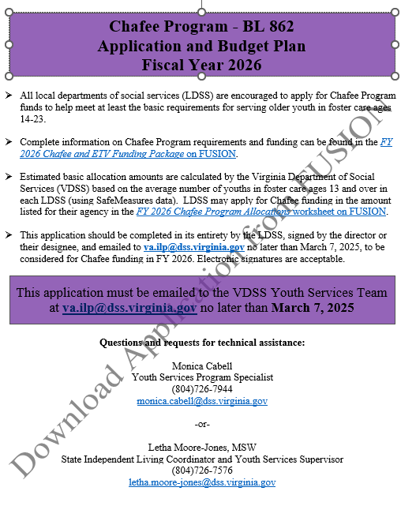
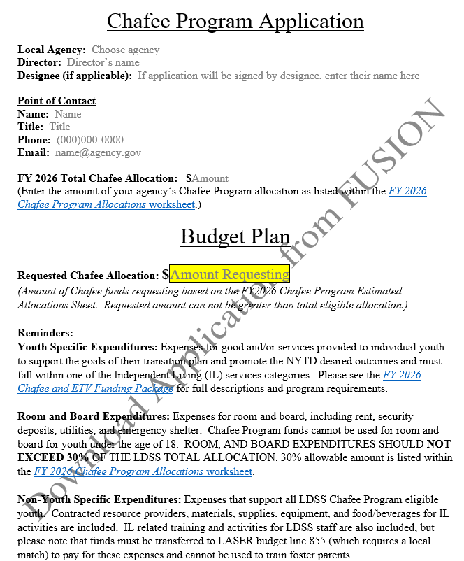
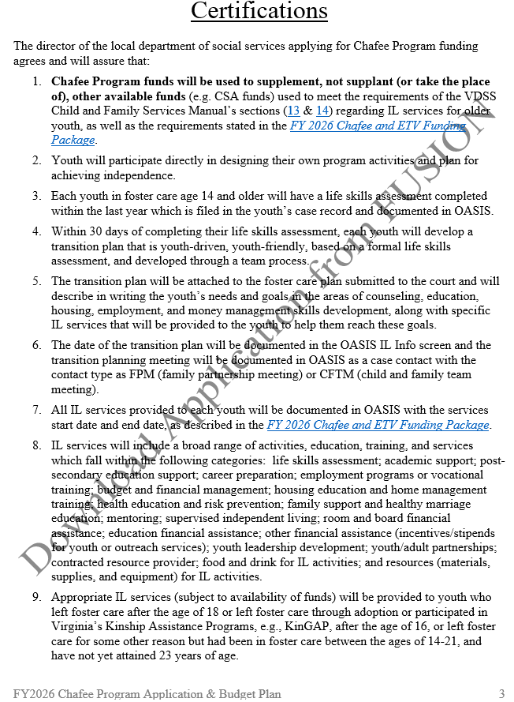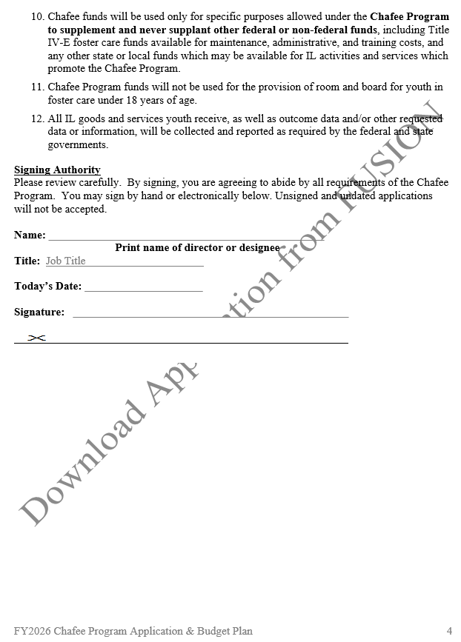

APPENDIX B
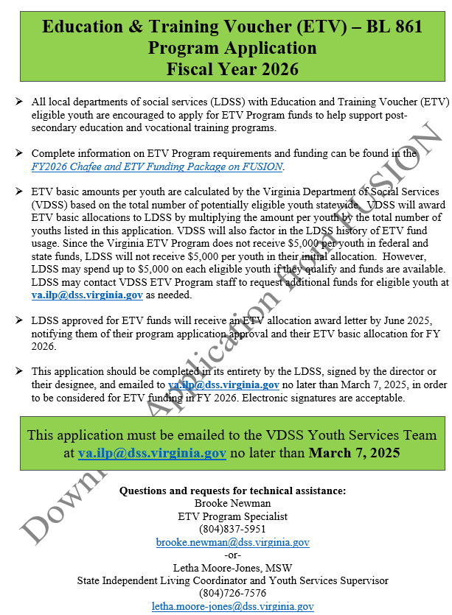
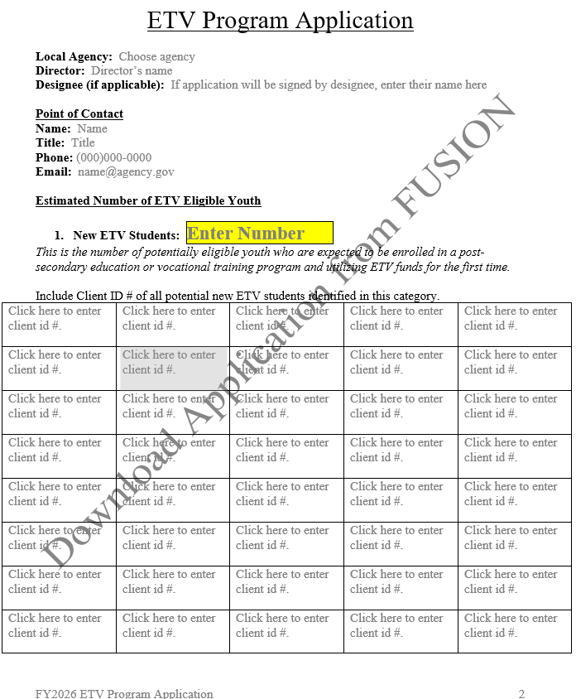
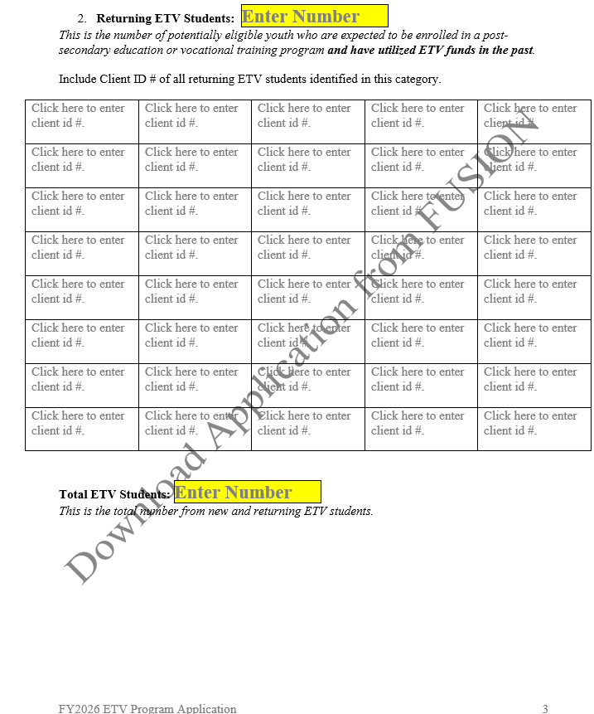

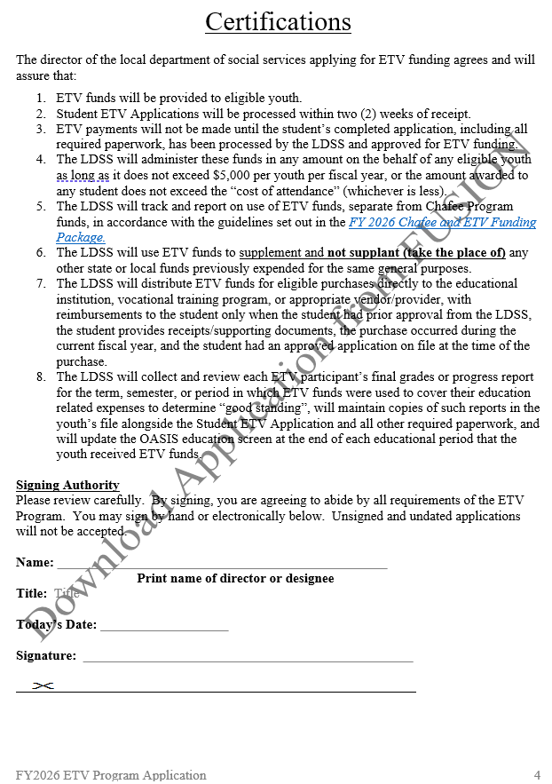

APPENDIX C

VDSS Chafee Program

Quick Reference Guide

FY 2026
Important Funding Dates

- March 7, 2025 – FY 2026 Chafee Program Funding Application due
- June 1, 2025 – FY 2026 allocations available in LASER
- September 12, 2025 – 1st quarter report due
- December 12, 2025 – 2nd quarter report due AND mid-year review
- March 13, 2026 – 3rd quarter report due
- May 31, 2026 – all FY2026 Chafee Program funds must be utilized or returned
- June 19, 2026 – 4th quarter report due

Youth Eligibility

- At least 14 years of age and not yet 23 years of age; AND
- In foster care (including Fostering Futures) in Virginia; or
- Left foster care* after the age of 18; or
- Left foster care* through adoption or participated in a Kinship Assistance Program after the age of 16; or
- Had been in foster care between the ages of 14 and 21 and left for some other reason*
*Youth who left foster care and are no longer receiving services are eligible for limited services or financial assistance if funding is available, as well as participation in group IL activities provided by the LDSS, VDSS, or contracted resource providers if space is available.

Program & Documentation Requirements

- All Chafee Program-eligible youth must have a life skills assessment and transition plan completed and updated at least annually. Copies are to be retained in the youth’s file and must be documented in OASIS in the IL info screen.
- The life skills assessment must be done within the 30 days prior to completing/updating the transition plan. Transition planning is a youth-driven, team process. The planning meeting is to be documented as an OASIS contact with the contact type “Family Partnership Meeting” or “Child and Family Teaming Meeting”.
- Youth turning 18 years old must have a transition plan completed/updated within the 90-days prior to their 18th birthday.
- All IL services must be reported in the quarterly report and documented in the youth’s OASIS IL services screen.
- All Chafee Program-eligible youth must have their OASIS education screen up to date.
- Receipts and invoices must be kept in the youth’s file for all goods and services provided through Chafee funding.
- All funds must be utilized by May 31, 2026. Any unused funds should be returned as soon as possible via BRS request in LASER.

Questions? Contact the VDSS Youth Services Program Specialist at va.ilp@dss.virginia.gov or (804) 726-7944

VDSS ETV Program

Quick Reference Guide

FY 2026

Important Funding Dates

- March 1, 2025 – FY 2026 ETV Program Funding Application due
- June 1, 2025 – FY 2026 allocations available in LASER
- September 12, 2025 – 1st quarter report due
- December 12, 2025 – 2nd quarter report due AND mid-year review
- March 13, 2026 – 3rd quarter report due
- May 31, 2026 – all FY 2026 ETV Program funds must be utilized
- June 19, 2026 – 4th quarter report due

Youth Eligibility

- At least 14 years of age and not yet 26 years of age
- In foster care (including Fostering Futures), left foster care after the age of 18, or left foster care through adoption or participated in a Kinship Assistance Program after the age of 16 in Virginia
- Have received their high school diploma or GED certificate
- Have applied for financial aid through the post-secondary school or training program they will attend or participate in, if applicable
- Be enrolled full-time or part-time in a post-secondary education or training program
- Make satisfactory academic progress by maintaining at least a cumulative grade point average of 2.0 on a 4.0 scale or have an academic standing consistent with the institution’s graduation requirements for the federal student financial aid program
- Receive up to $5,000 per year or the total cost of attendance (whichever is less)
- Receive ETV for up to 5 years (whether consecutive or not)

Application Requirements

- Completed application on file annually
- Federal financial aid application completed (if applicable)
- Proof of enrollment
- Cost of attendance summary
- Most recent transcript or progress report

Other Program Requirements
- Expenses must be documented in OASIS (IL services screen) and receipts kept on file.
- Youth’s OASIS education screen must be updated per semester or quarter.
- All funds must be utilized by May 31, 2026. Any unused funds should be returned as soon as possible via BRS request in LASER.

Questions? Contact the VDSS Youth Services Program Specialist at va.ilp@dss.virginia.gov

